

Lab No:02 Date:2082/09/13
Title: Create object types in Object Oriented database and insert some of the values in such tables.
This project demonstrates the use of Object-Oriented features in Oracle Database by creating user-defined object types and object tables. It involves defining object attributes and methods, and inserting sample data to show how Oracle supports object-oriented data modeling and storage.
Create type is used to create a user-defined data type in Oracle. It lets you group related data (attributes) into one object, just like a class in Object-Oriented Programming.
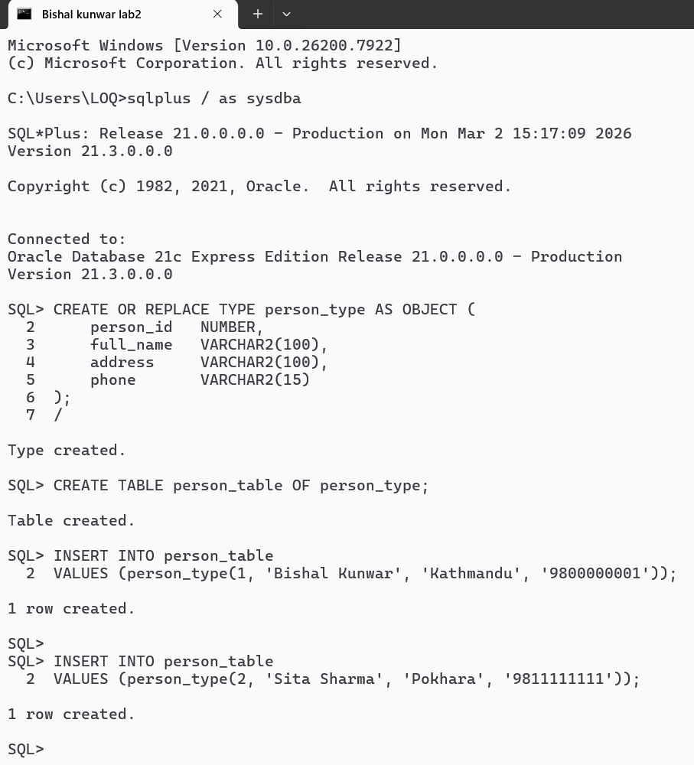

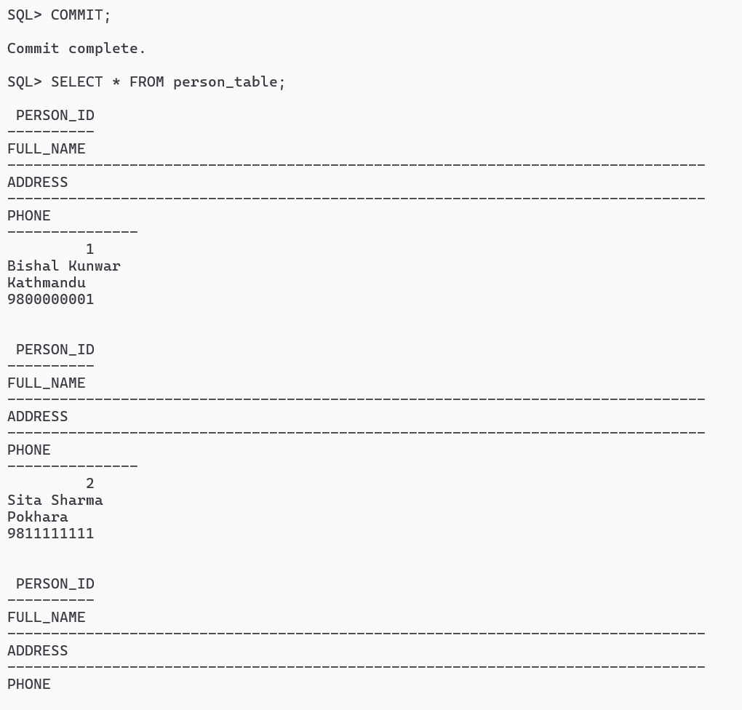
In SQL*Plus, when you run DML statements like INSERT, UPDATE, or DELETE, you do NOT need a ‘/ ‘ at the end.
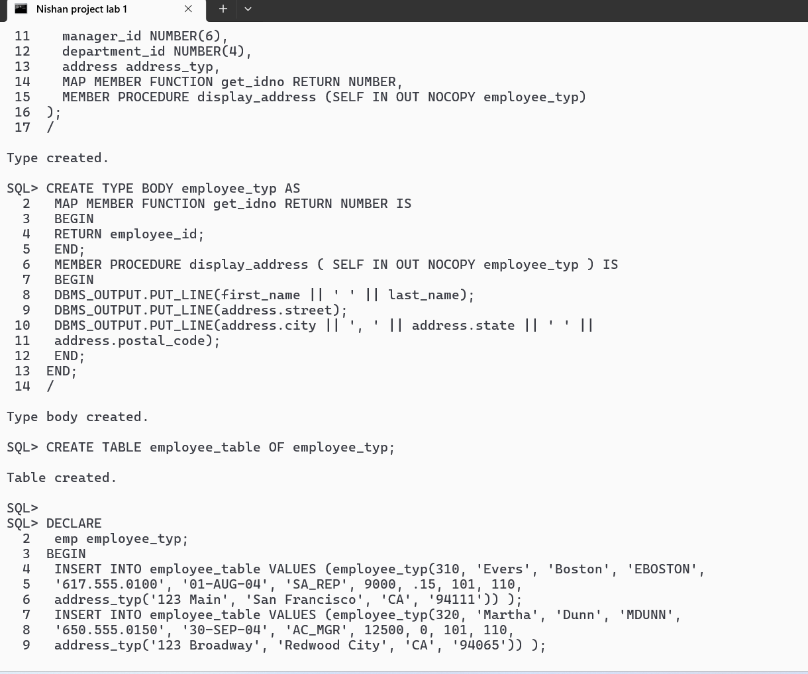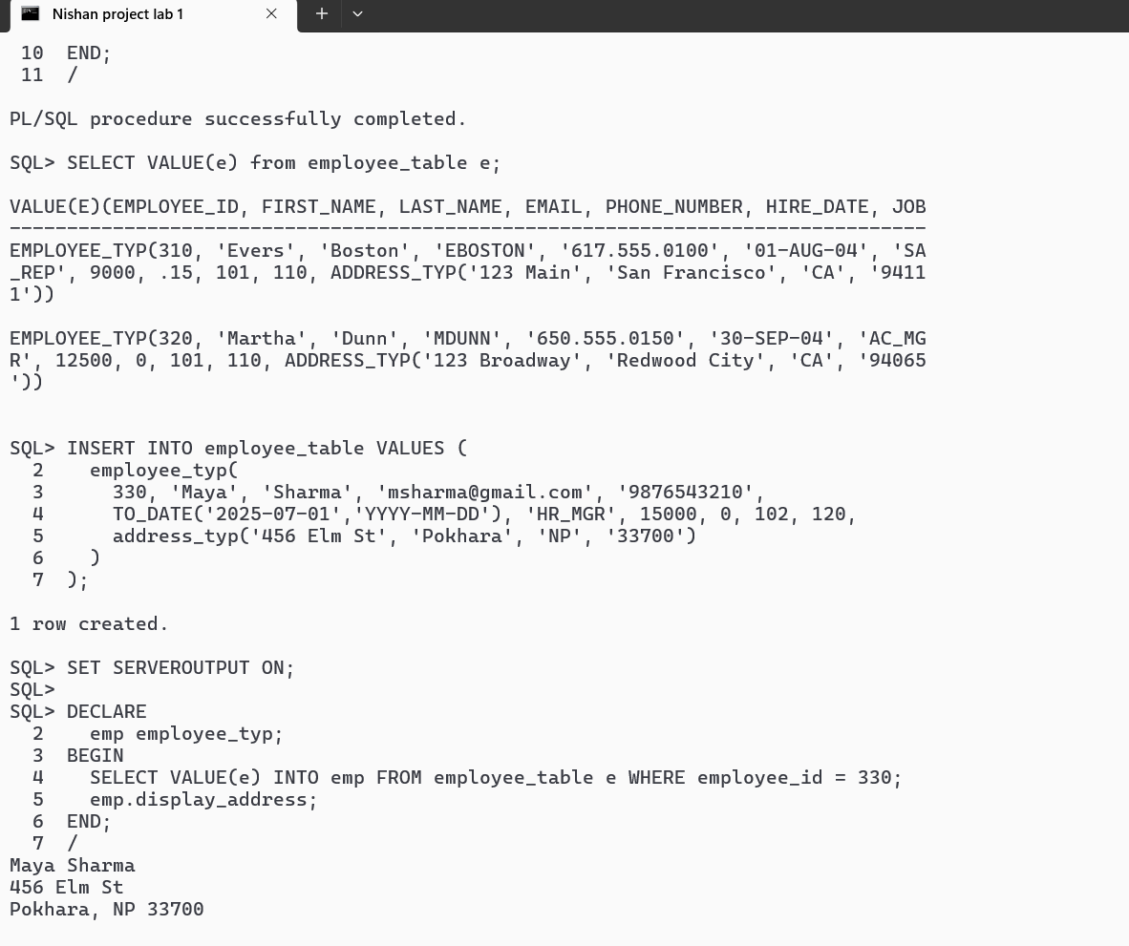

We created Oracle object types (employee_typ and address_typ) with attributes and member methods. We stored employee objects in an object table and inserted sample data with nested addresses. We queried the table to retrieve full objects and specific attributes,

and used member procedures to display information. This demonstrates Oracle’s support for object-oriented data modeling and manipulation.
In this project, we implemented Oracle’s object-oriented features by creating user-defined object types and nested objects. We created an employee_typ object type with attributes and member methods, and stored instances in an object table. We performed operations like inserting data, selecting specific attributes, and using member procedures to display nested object information. This demonstrates how Oracle supports object-oriented data modeling and manipulation alongside traditional relational features.

